CSCI Assignment 4 – Secure Email Using OpenPGP
Name: Arinze Chukwuemeka
Instructor: Dr. Yingbing Yu

Objective
The objective of this assignment was to configure secure email communication using OpenPGP encryption. Since I completed the assignment on macOS, I used GPG Suite (the macOS equivalent of Gpg4win) together with Mozilla Thunderbird to generate OpenPGP key pairs, configure end-to-end encryption, exchange public keys, and securely send and receive encrypted and digitally signed email messages between two Gmail accounts.

Email Accounts Used
- Account 1: rrinzebp@gmail.com
- Account 2: arinzechukwuemeka12@gmail.com

Step 1 – Generate OpenPGP Key Pairs
I generated an OpenPGP public/private key pair for each Gmail account using GPG Keychain. The keys were successfully created and are available for encryption, decryption, digital signing, and signature verification.
Screenshot 1: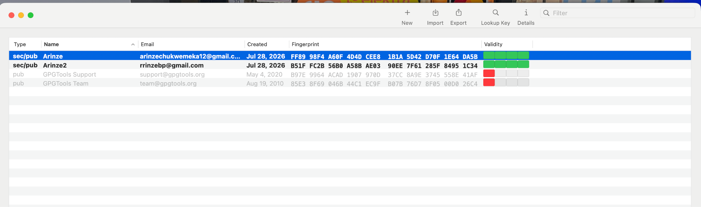

Step 2 – Configure Thunderbird
Both Gmail accounts were successfully added to Mozilla Thunderbird using IMAP. I verified that each account could successfully send and receive standard (unencrypted) email messages.

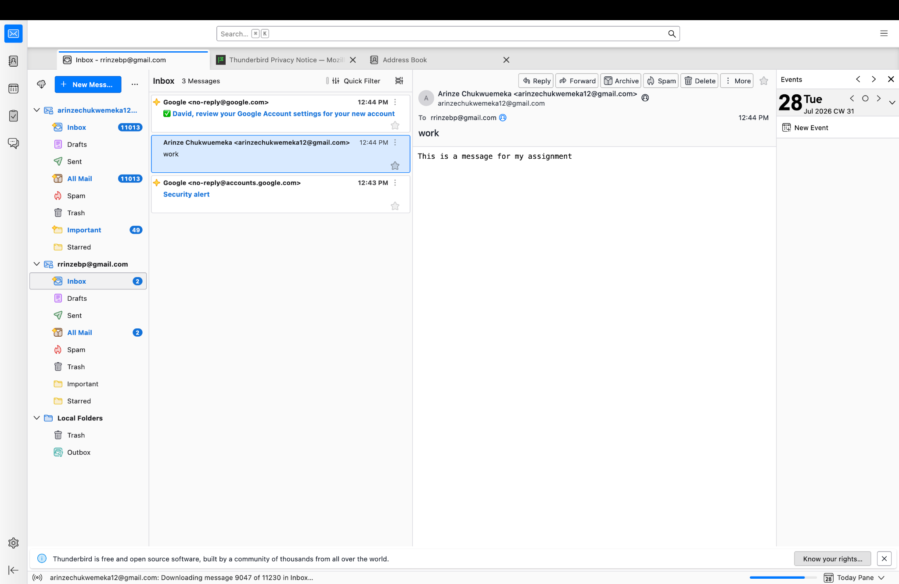

Step 3 – Import OpenPGP Keys into Thunderbird
The OpenPGP public and private keys were imported into Thunderbird. End-to-end encryption was enabled for each email account by selecting the appropriate OpenPGP key.
Screenshot 4:
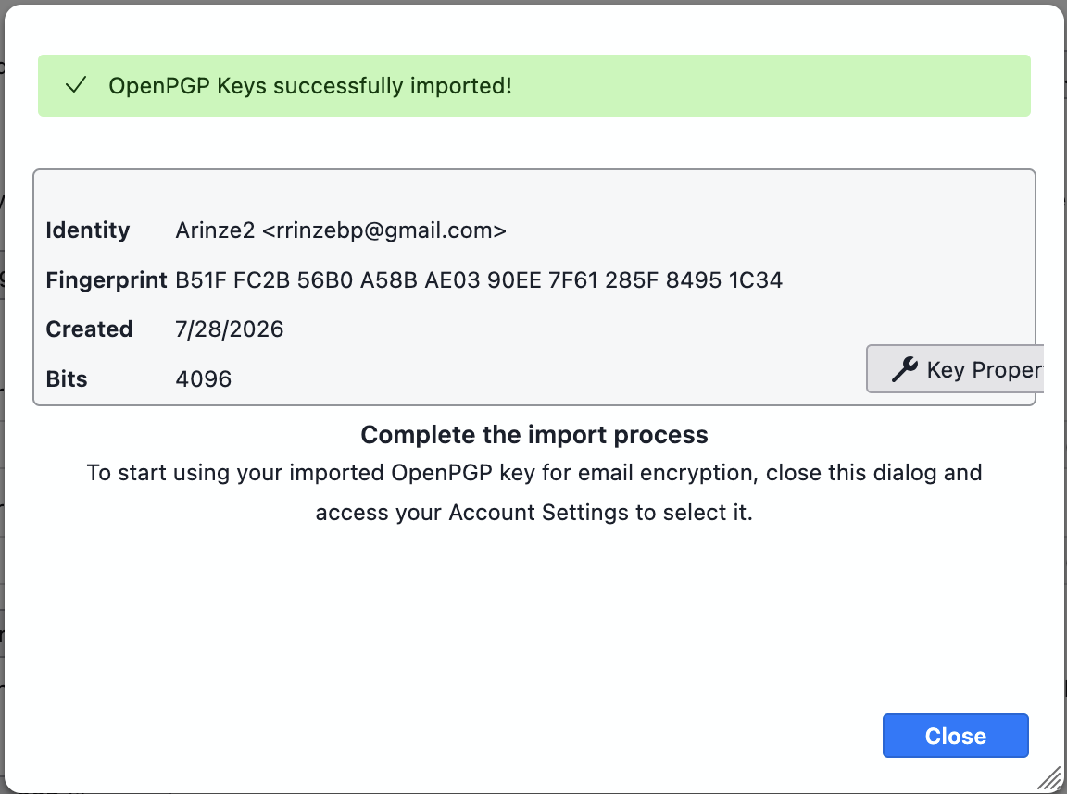
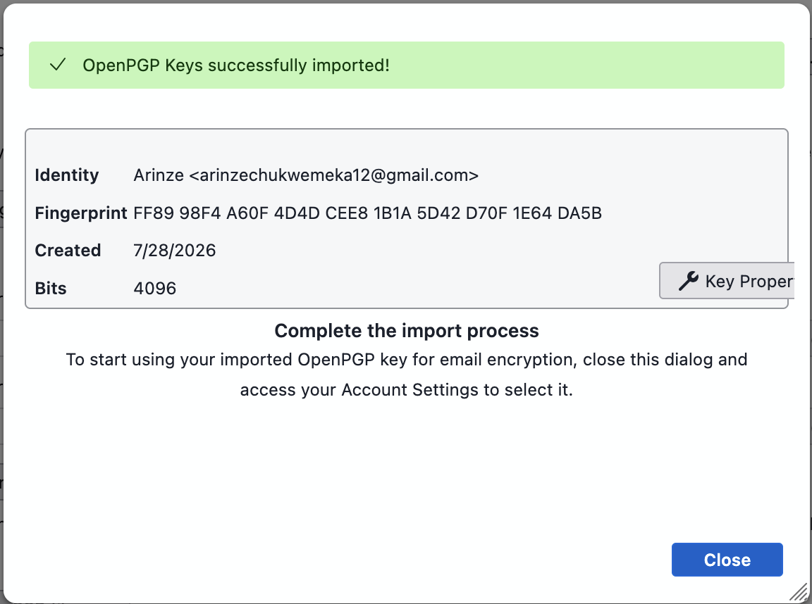
Screenshot 5:
(screenshot showing the End-to-End Encryption settings with the selected OpenPGP key.)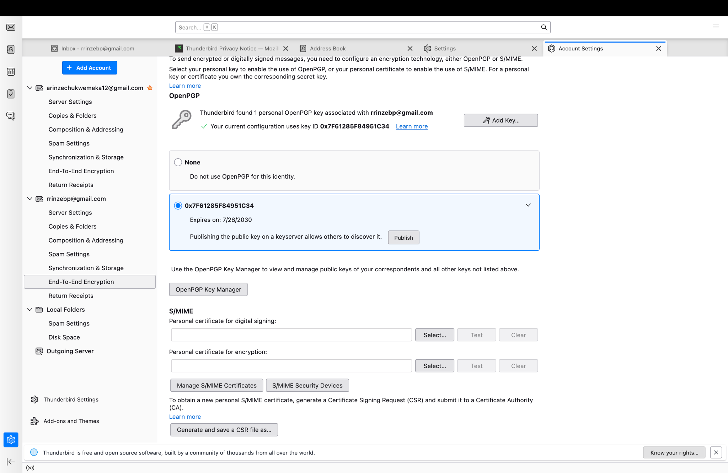
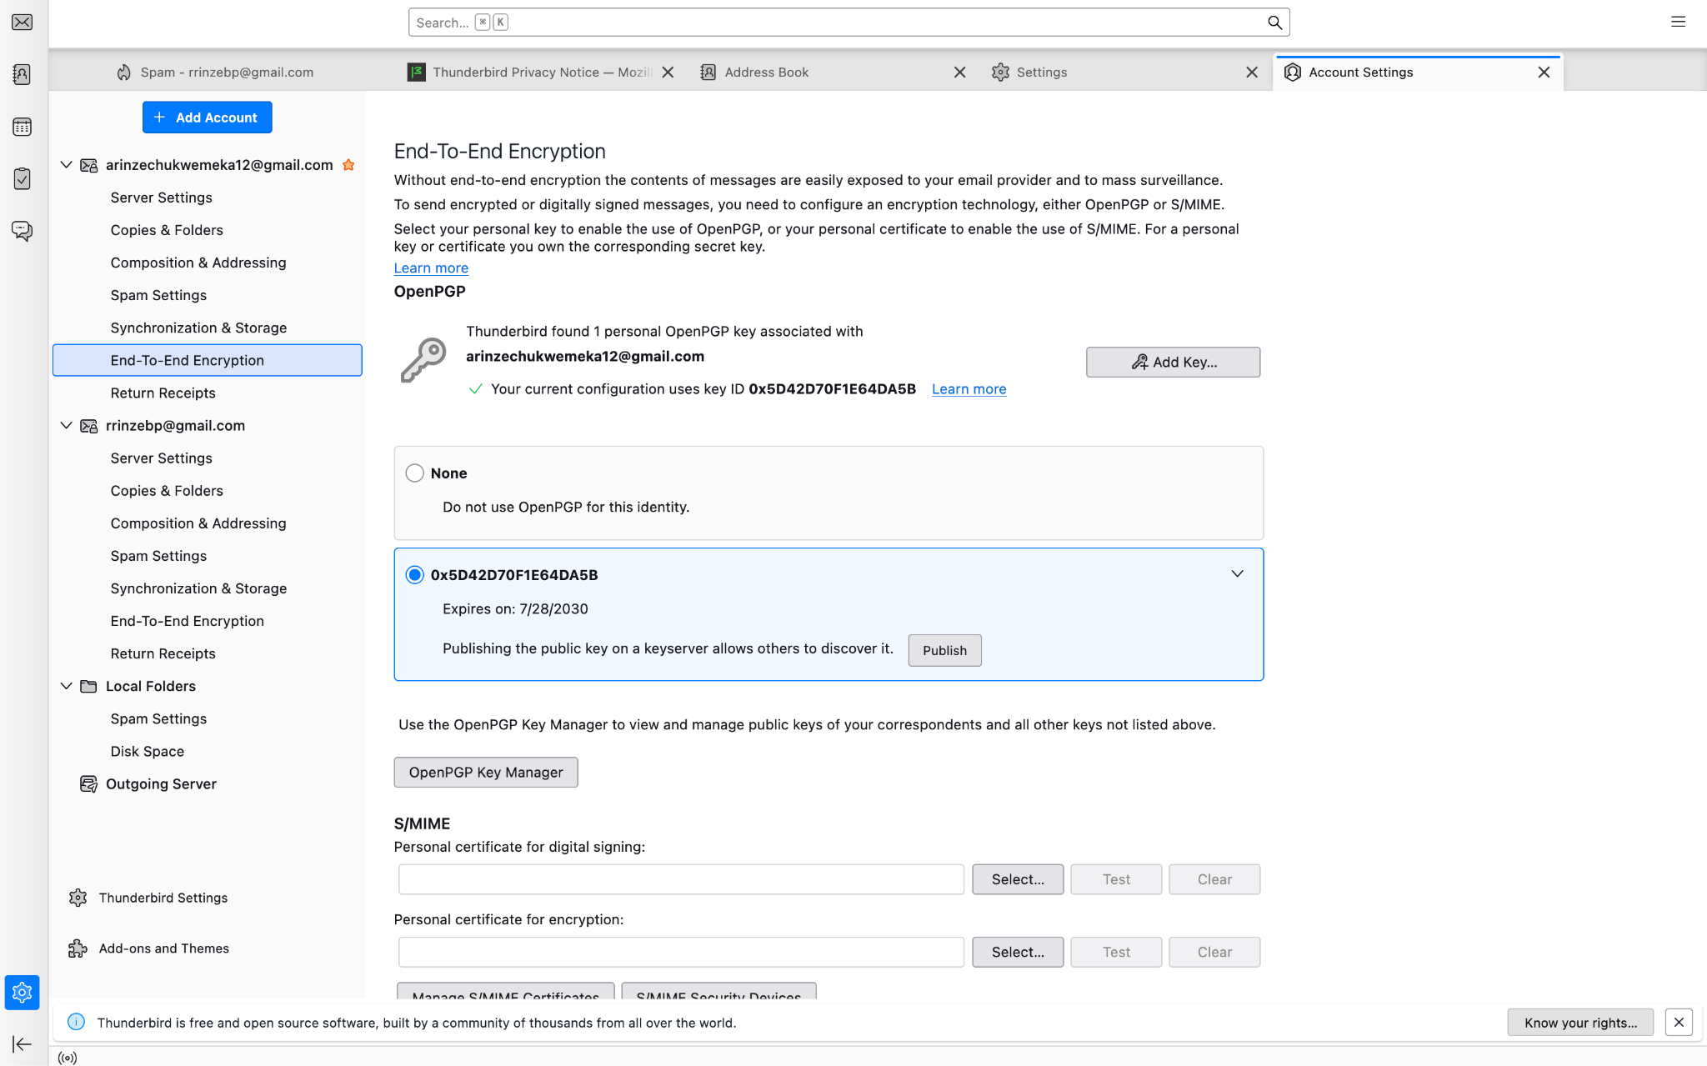

Step 4 – Exchange Public Keys
Each email account imported the other account’s public key so encrypted communication could be established. This allows messages to be encrypted using the recipient’s public key while only the recipient’s private key can decrypt the message.
Screenshot 6:
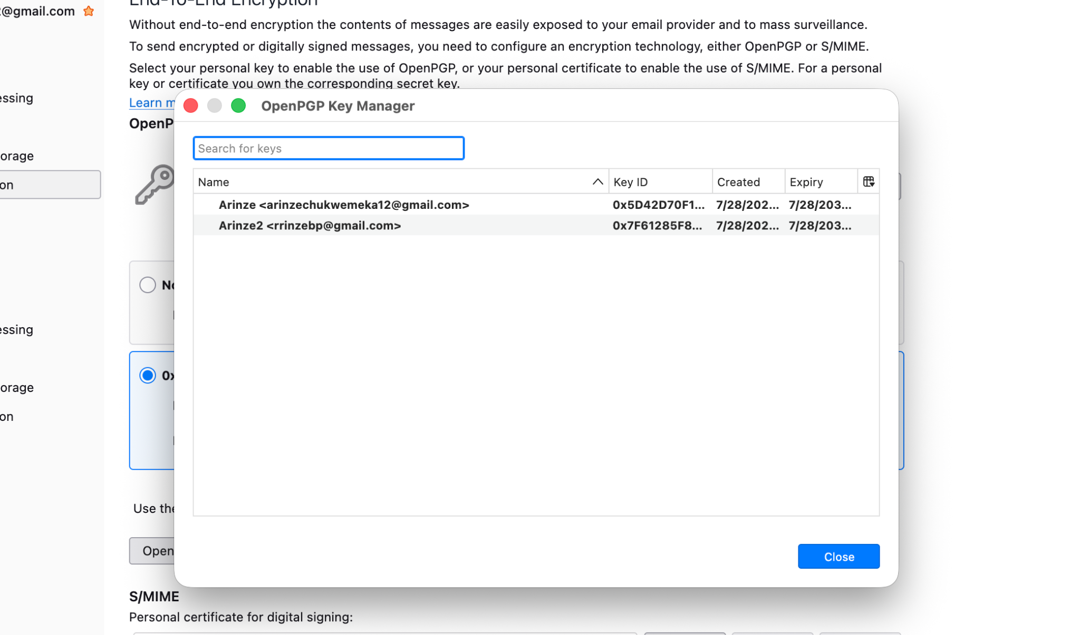

Step 5 – Send an Encrypted and Digitally Signed Email
An encrypted and digitally signed email was sent from one Gmail account to the other using Thunderbird’s OpenPGP functionality.
Screenshot 7:
(screenshot showing the email being composed with encryption and digital signing enabled.)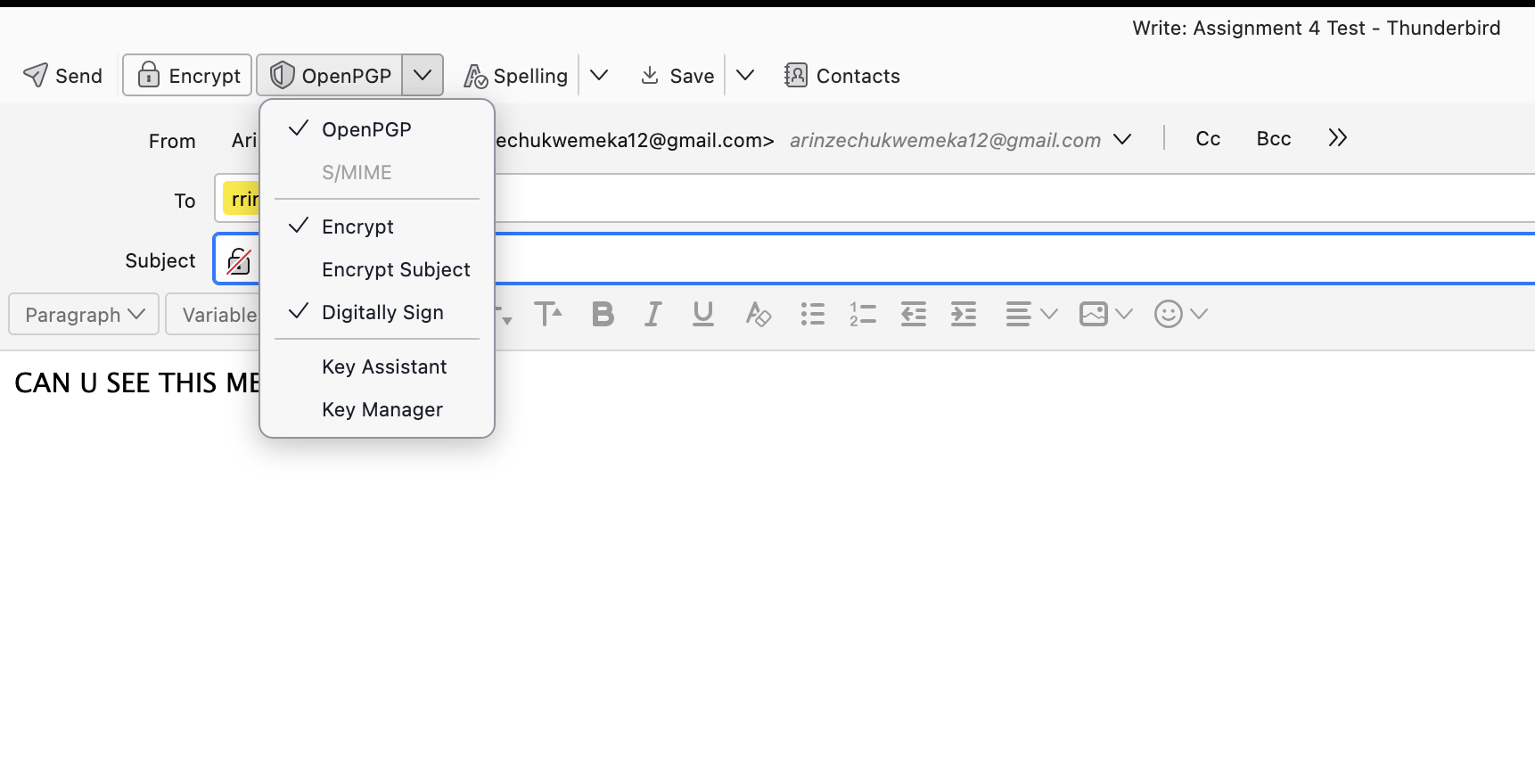

Step 6 – Receive and Decrypt the Email
The encrypted email was successfully received and automatically decrypted using the recipient’s private OpenPGP key.
Screenshot 8:
(screenshot showing the decrypted email in Thunderbird.)
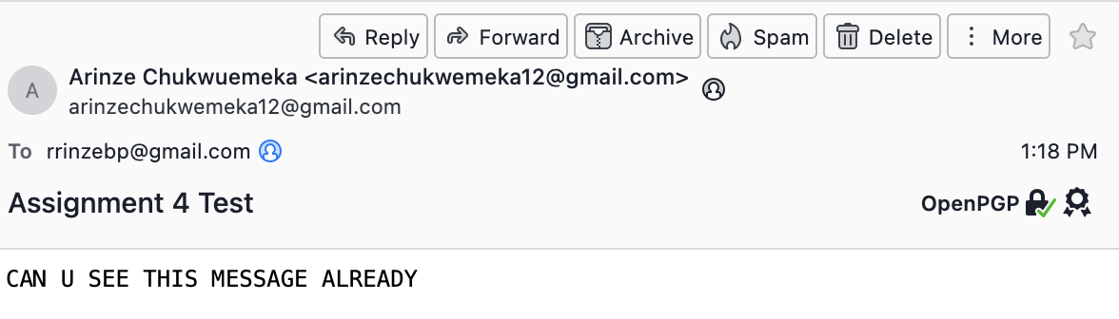

Step 7 – Verify the Digital Signature
The OpenPGP signature attached to the email was successfully verified, confirming both the authenticity of the sender and the integrity of the message.
Screenshot 9:
(screenshot showing the OpenPGP signature or certificate information.)
